Community Infrastructure Levy
Annual Report for Haresfield Parish Council
1st April 2021 – 31st March 2022
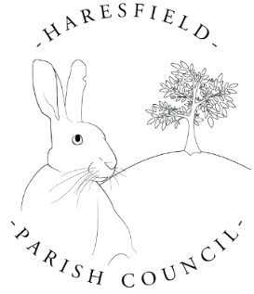
Your Logo

Delivered in partnership with

This report is published on 10th December 2022 by Haresfield Parish Council in accordance with the CIL Regulations 2010. Copies are made publicly available on our Parish Council website www.haresfield-pc.co.uk and this has been formally reported to our local CIL Charging Authority Stroud District Council www.stroud.gov.uk.
Produced by: M J King (Clerk to Haresfield Parish Council)
Contact details: …haresfieldpc@gmail.com

CIL Neighbourhood Payment | Amount
CIL Receipts for April 2021 | £0
CIL Receipts for October 2021 | £335.89
Total CIL Income 2021/22 | £
Balance carried over from previous financial years | £0
Total Available Budget for 2021/22  (this includes any CIL monies received in previous years which may have been retained) | £335.89
Total Expenditure 2021/22  (full details over page) | £0
Total Retained 2021/22  (to be carried over to 2022/23) | £335.89

* CIL receipts must not be kept on account for more than 5 years in line with legislative requirements.

Community Infrastructure Project 1:

Project name and location:

Brief description of works undertaken:

Date Project Completed:

Has the project been successful? How?

Total Project Costs: ......................................................  Summary of match funding secured: ..........................  Amount of CIL expenditure committed: ...................... | £  £  £

[Please copy and paste this table for each individual project you wish to report]

Further information on the Community Infrastructure Levy in the Stroud District
please visit the Planning pages at www.stroud.gov.uk

